1. Draw a line from the picture to the correct force

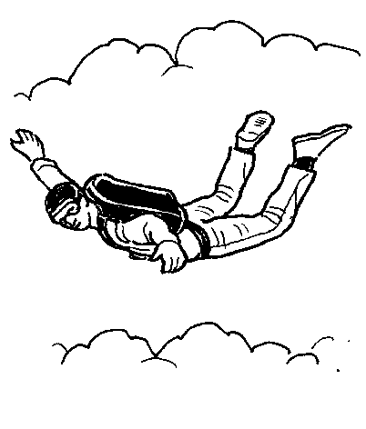 | 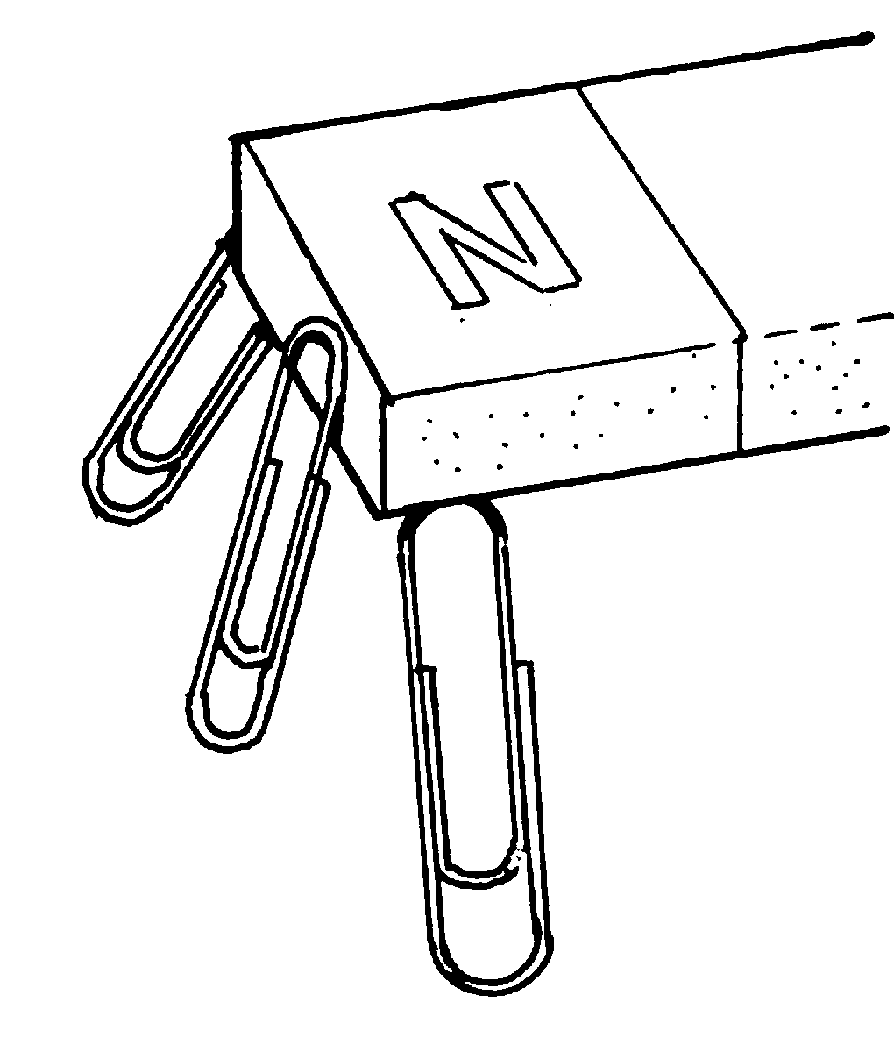 | 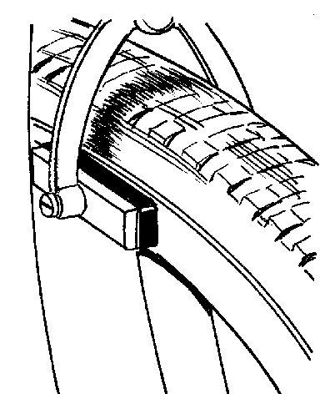 | 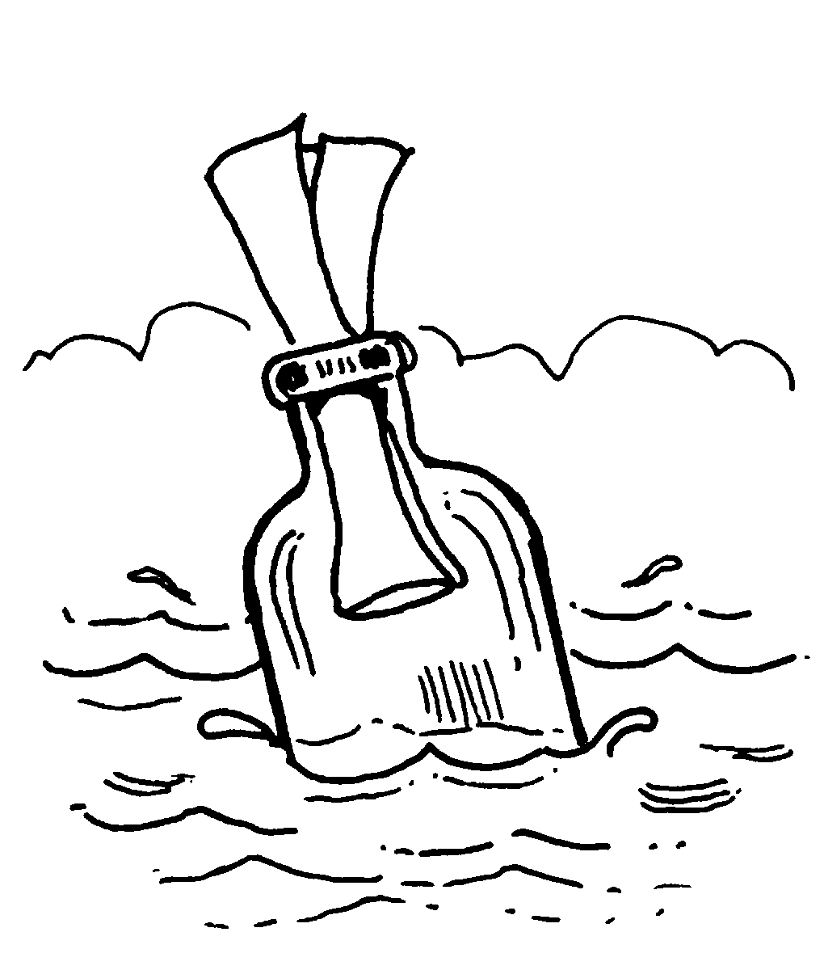 | 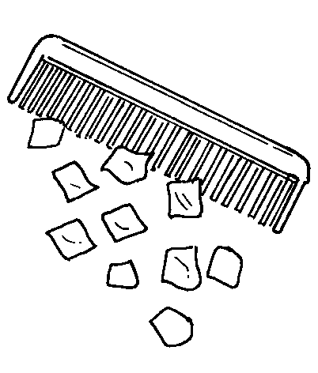

Magnetism | Static  electricity | Friction | Gravity | Upthrust

2. Which forces are pushes and which ones are pulls? Write the correct words in the spaces.

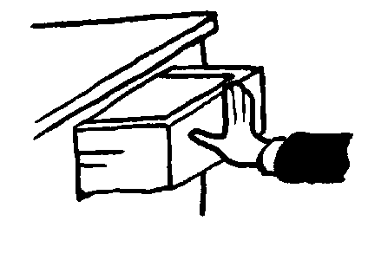 | 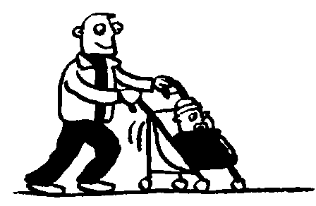 | 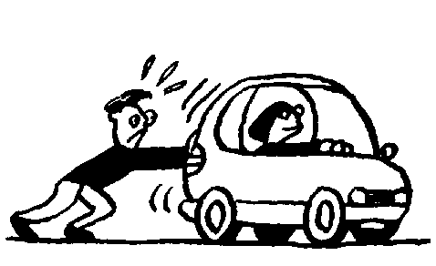 | 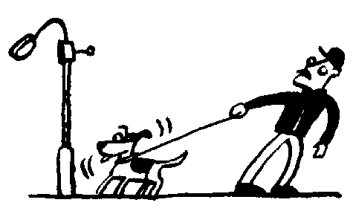
_________________ | _________________ | _________________ | _________________

3. Look at the pictures below. Write the names of the forces next to the arrows.

A | 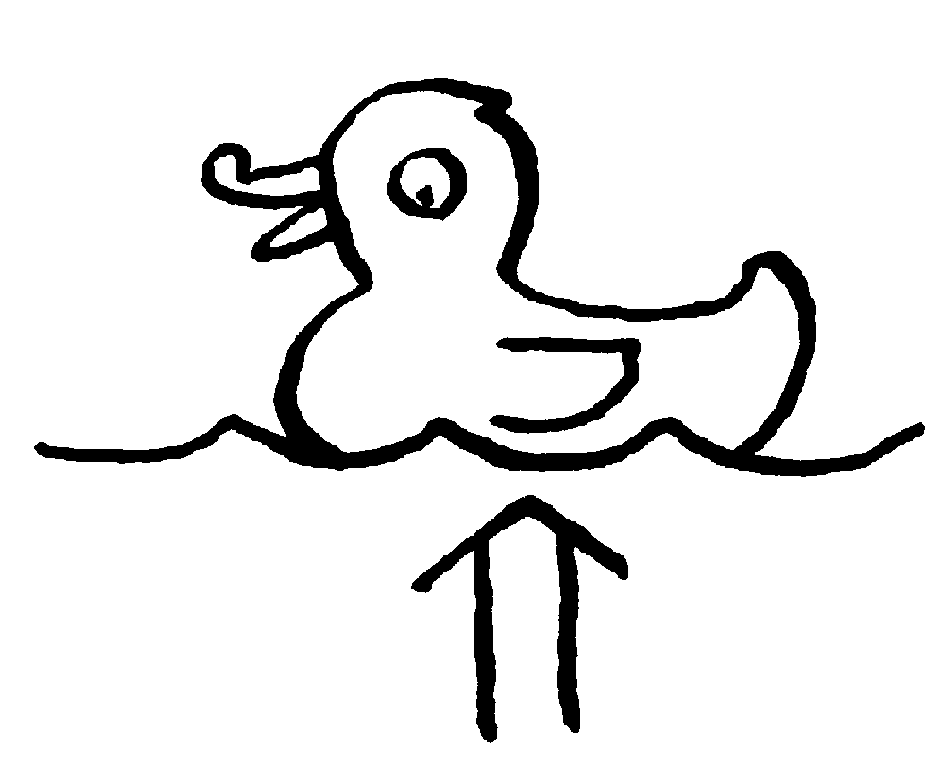  _____________ | B | 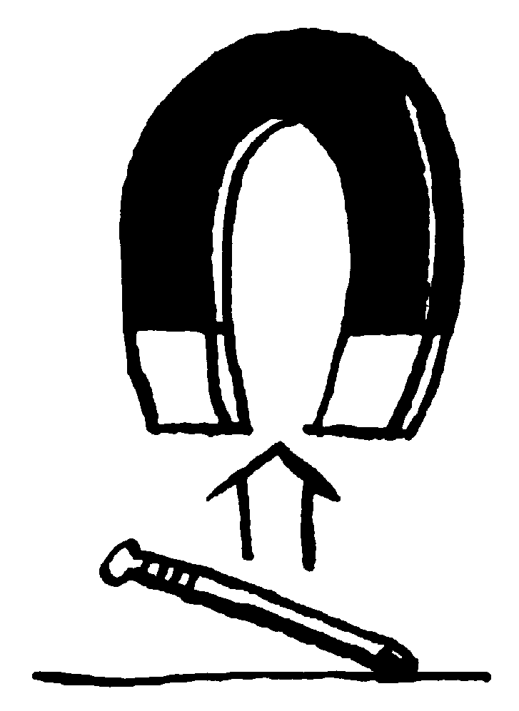  _____________ | C | 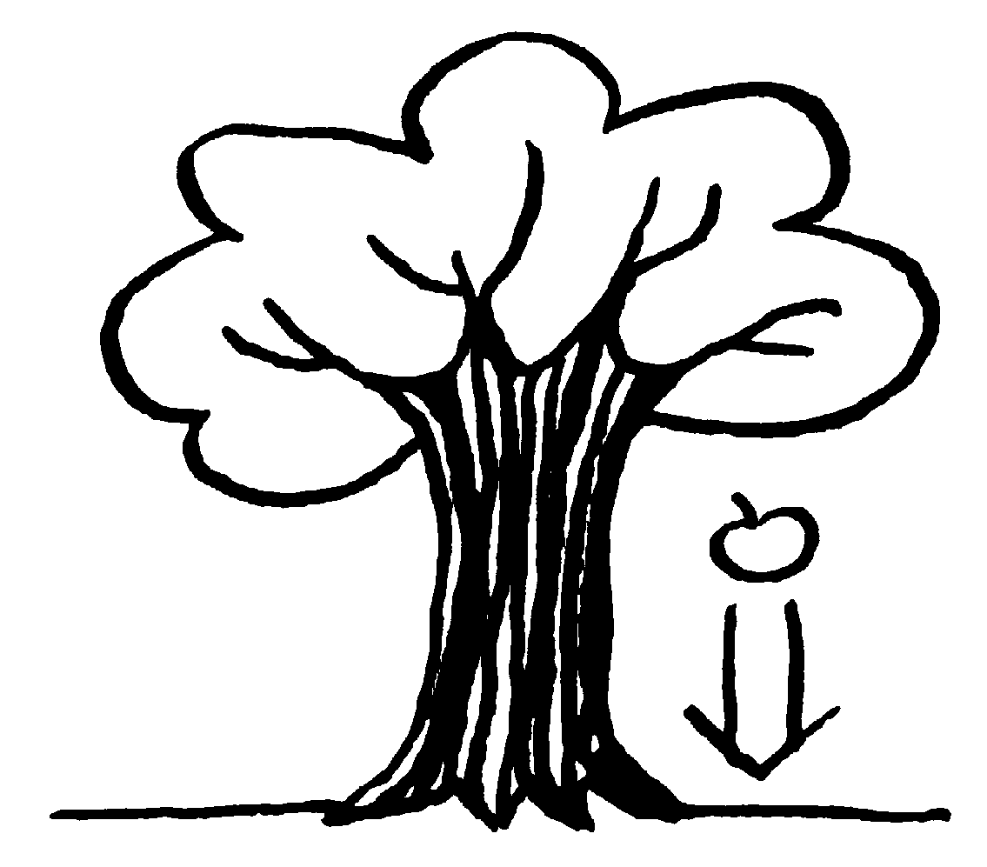  _____________
D | 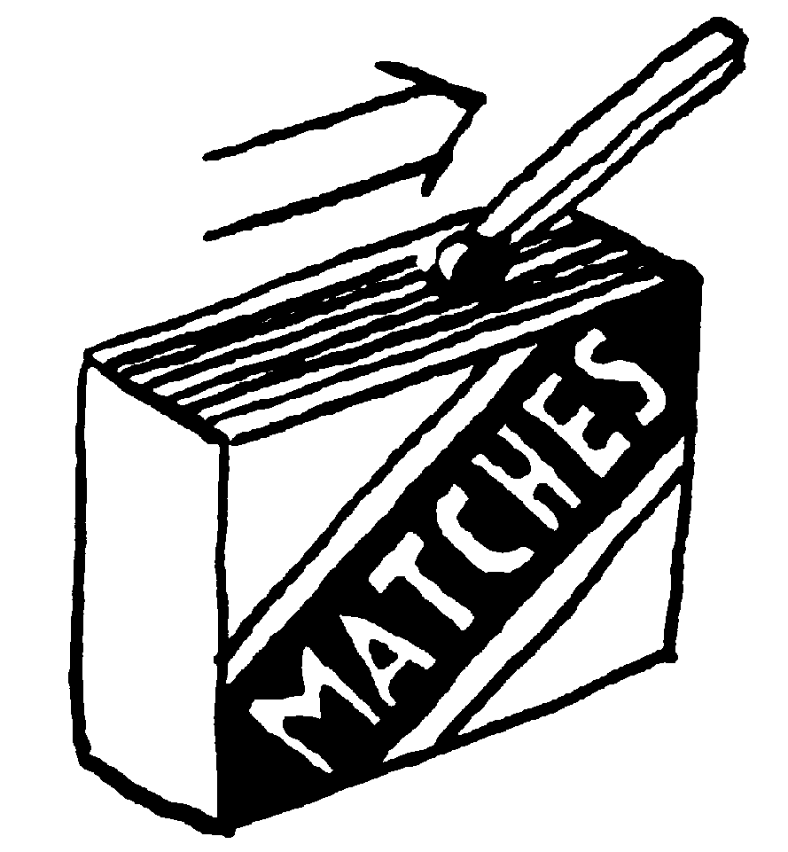  _____________ | E | 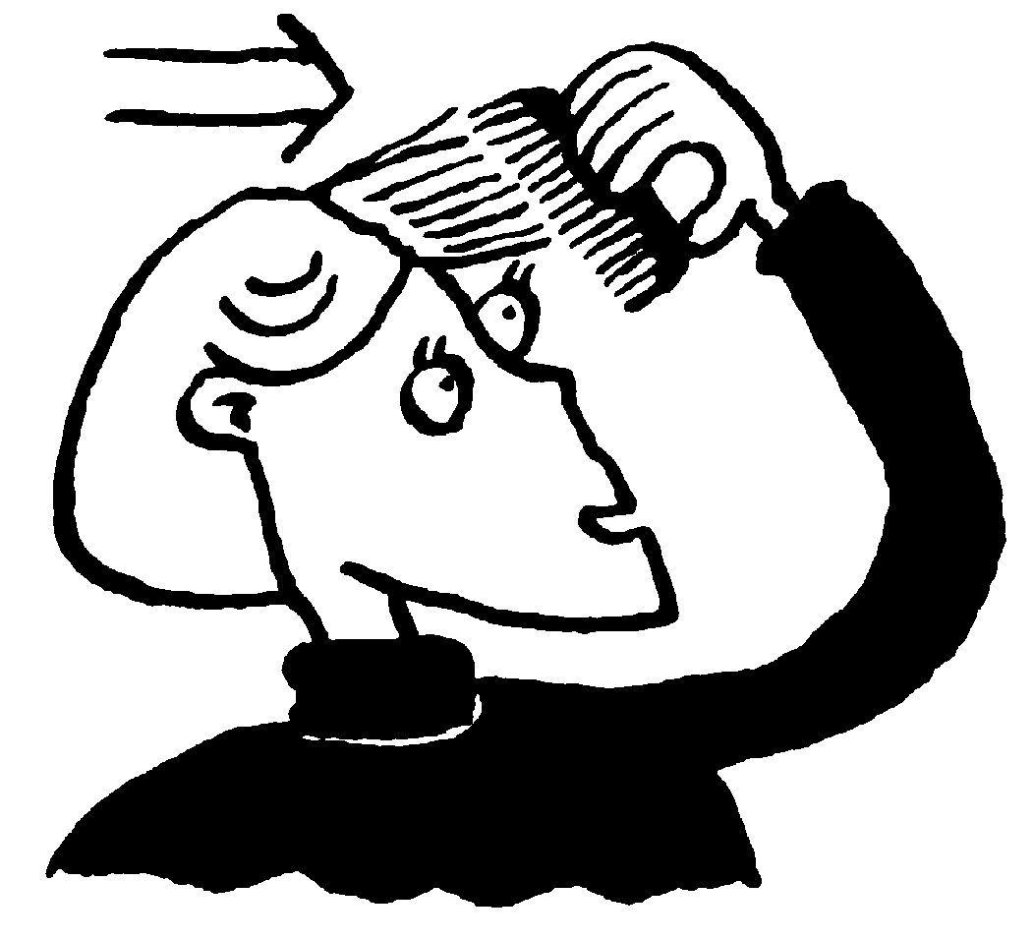  _____________ | F | 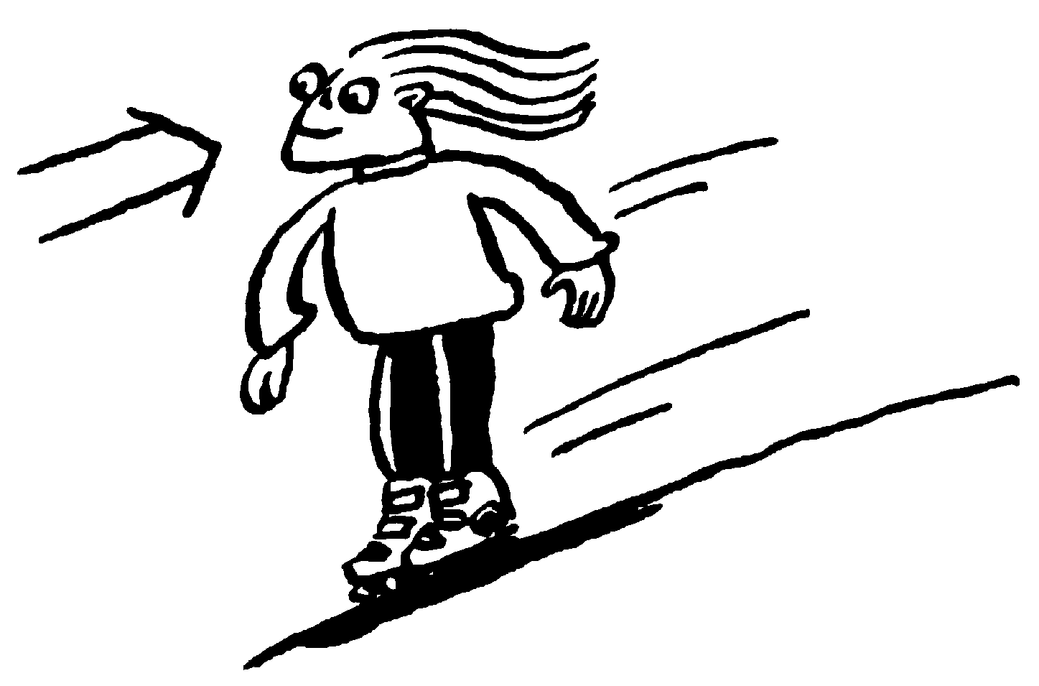  _____________

4 Which pictures show non-contact forces? ___________________

5 Complete these sentences.

a A ___________________ is needed to start an object moving.

b A force can change the ___________________ , ___________________

and ___________________ of an object.

c Nothing starts to move without a ___________________ being involved.

d Three forces which can act from a distance are ___________________ ,

___________________ and ___________________ ___________________

forces.

